**Project 1**

Luyao Zhang

**EAP estimation**

1. EAP is an alternative method for ability estimation, besides ML and MAP. It belongs to the Bayesian method, and one thing that EAP is capable of while ML is not is that it can deal with even all-correct or all-incorrect response pattern.
2. EAP contains “AP” which stands for “a posterior”, referring to the predicted distribution of latent trait scores given the response pattern and estimated model parameters of a case, and “E”, which stands for “expected”, which in statistics simple means to take average. Therefore, the procedure of EAP estimation is to figure out the expected value of the posterior probability distribution of latent trait scores given a case.

**EAP approximation step by step in this project**

1. We set a certain number of theta values (in our case, from -4 to 4, and the number is 31) as quadrature nodes.
2. Given that the prior distribution is standard normal, we can obtain the weights at each quadrature node using the formula below:



In the equation above, “int” is the interval between to quadrature nodes that are next to each other, which in our case is 8/31.

1. We already know that



And because the prior distribution is standard normal, EAP can be approximated using the equation below:



In this equation,  is the likelihood function evaluated at each of the 31 quadrature nodes, and  represents the  values of the 31 quadrature nodes. To make it more feasible for practice, we replace the integration with summation.

**R code for EAP estimation**

1. Simulate responses using GRE item parameters for 40 items, and the theta values of 2000 students.

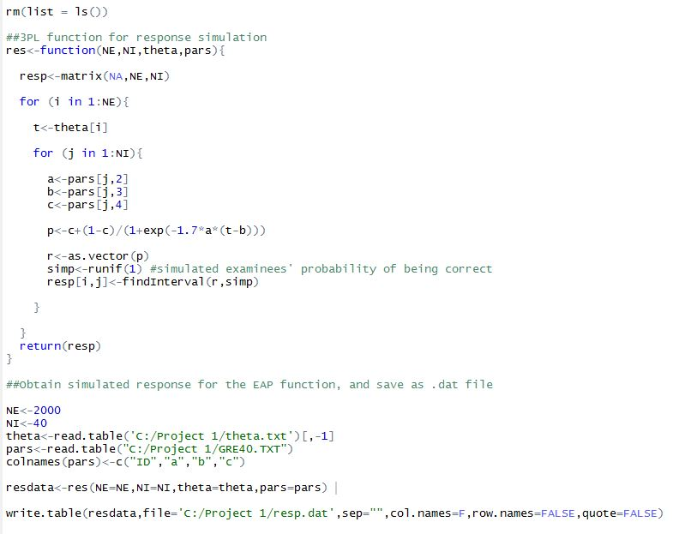

1. Function for calculation of probability for 3PL model.

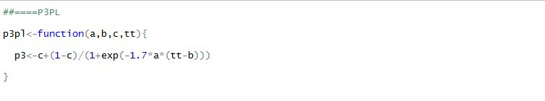

1. EAP function (setup and the main function)

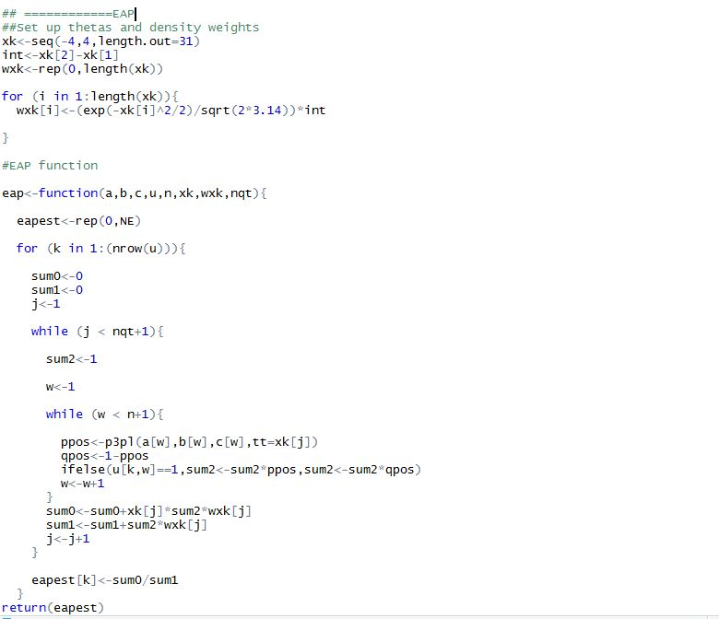

1. Run EAP with simulated response. Check for accuracy using plots, bias and MSE.

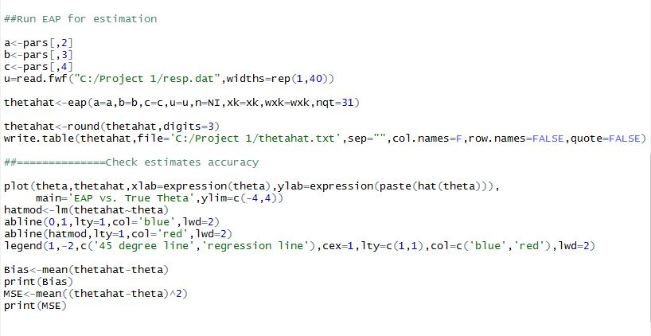

**Accuracy of EAP estimates**

1. By plotting EAP estimated theta against the true theta (plot as shown below) with 45 degree line and regression line, we can tell that the regression line deviates from the 45 degree line at both ends, which is consistent with our knowledge that EAP estimates is biased.

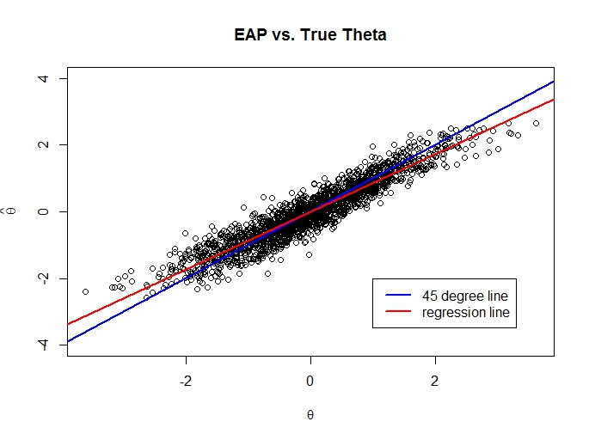

1. The bias is -0.006, which is very close to 0, and the MSE is 0.121. EAP estimated theta is highly positively correlated with true theta, r = 0.941. These statistics indicate that even though biased, EAP estimates is not a bad way to estimate abilities, especially when there are patterns of all-endorsed or all-not-endorsed.